Ideation Phase
Brainstorm & Idea Prioritization Template
Date | 28 September 2026
Team ID | SWTID-2026-2169
Project Name | Import Data Using Transform Map
Maximum Marks | 4 Marks
Brainstorm & Idea Prioritization Template:
Brainstorming gives the team a free and open space where everyone can take part in the creative thinking needed to solve the problem of importing data into Service Now. Quantity of ideas matters more than quality at this stage, so unusual ideas about uploading files, mapping fields, preventing duplicate records and fixing failed rows are welcome. Every team member is encouraged to build on each other's suggestions to create many practical solutions for a smooth import using a Transform Map.
Step-1: Team Gathering, Collaboration and Select the Problem Statement

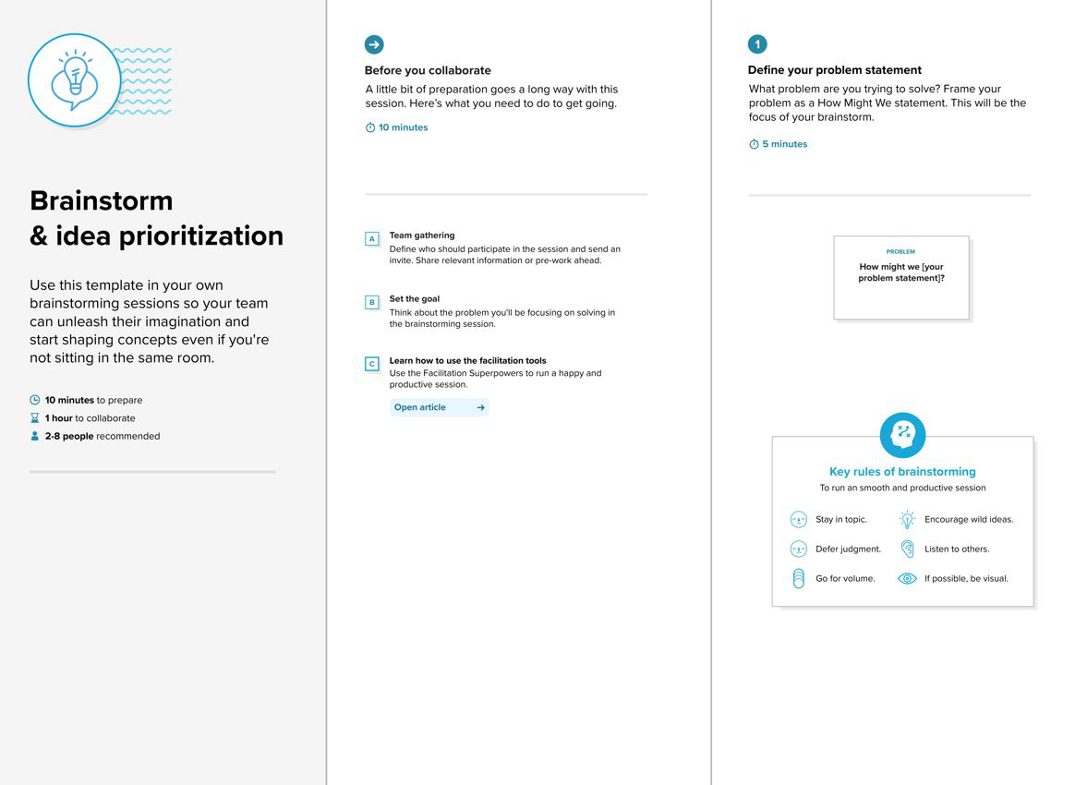

Step-2: Brainstorm, Idea Listing and Grouping

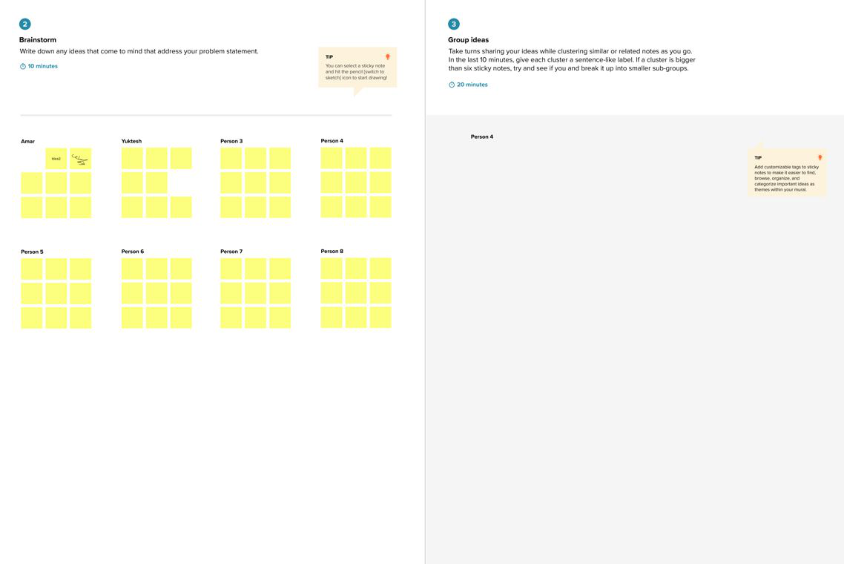

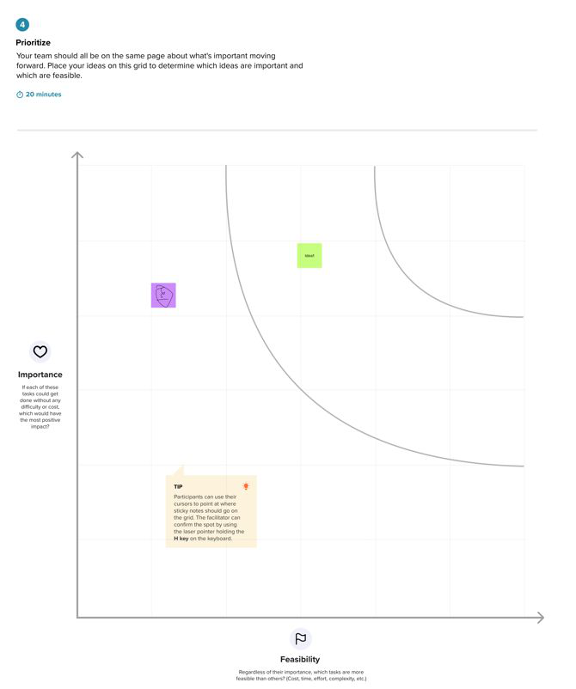
Step-3: Idea Prioritization

